Lazy Data Base Poject

LZDB is A python data base created for small data management (<10MB each table). It could read csv file, save csv, join, orderby, quickly access data, make a graph etc. The main propose of LZDB is to make coding about data base easy and efficient.

Some already finished function display:

1. basic print

code output

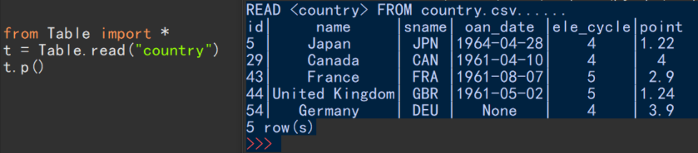

read function was intended to read all the data from .csv file and translate that into python 2d-list. including None, True, False, float, int and string

1. join on condition

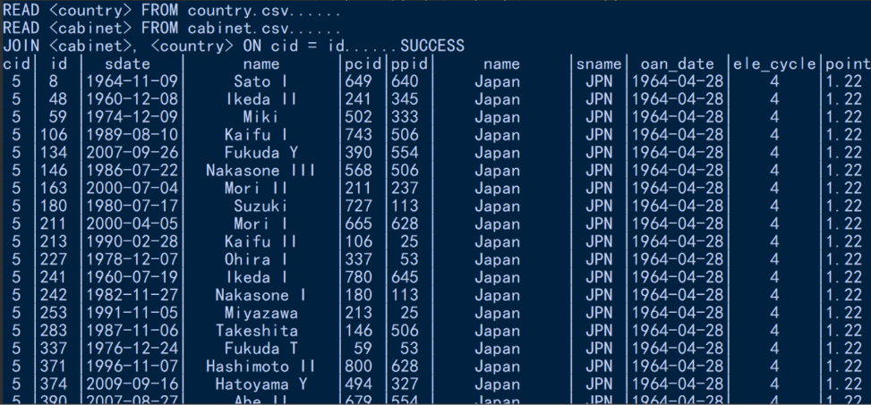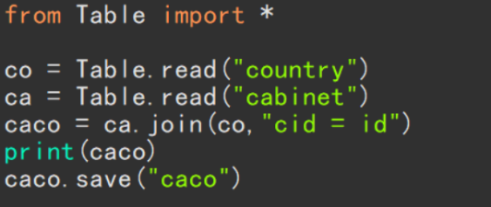code output

……

it joins the two table and ………

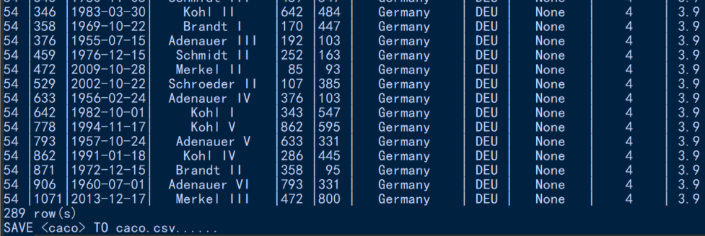save that to a new .csv file

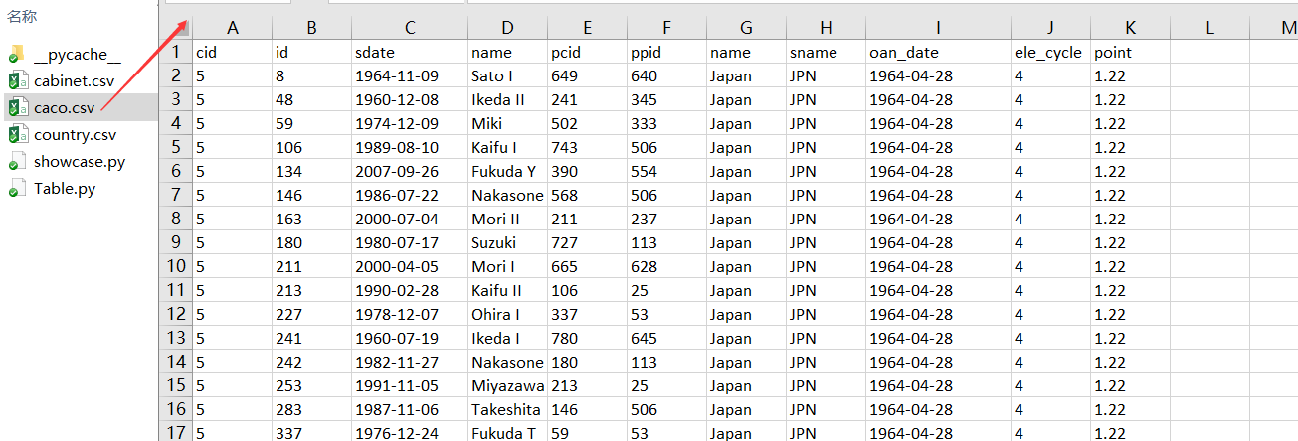

1. 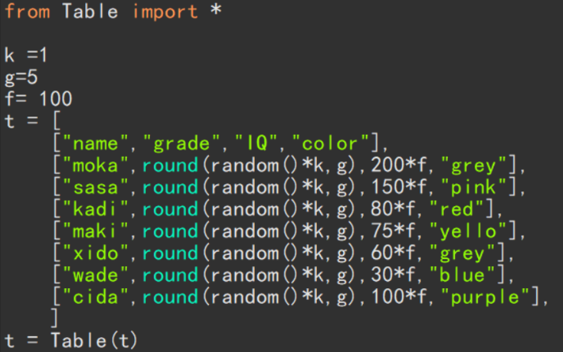display data

basic data code & graph

with matplotlib and github code

C:\Users\dell\AppData\Roaming\Tencent\Users\898356223\QQ\WinTemp\RichOle\)`@VPZ@)8ZQ8V`IG32N3H1A.png

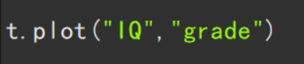

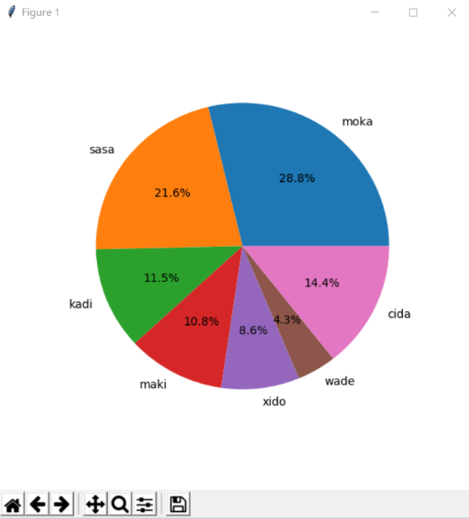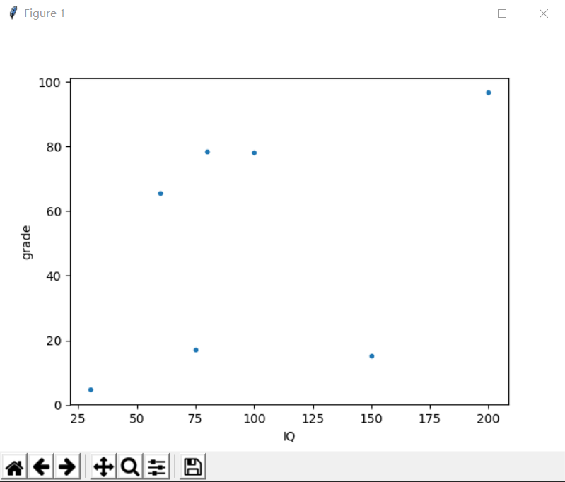

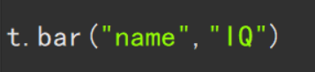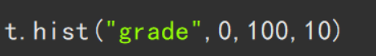

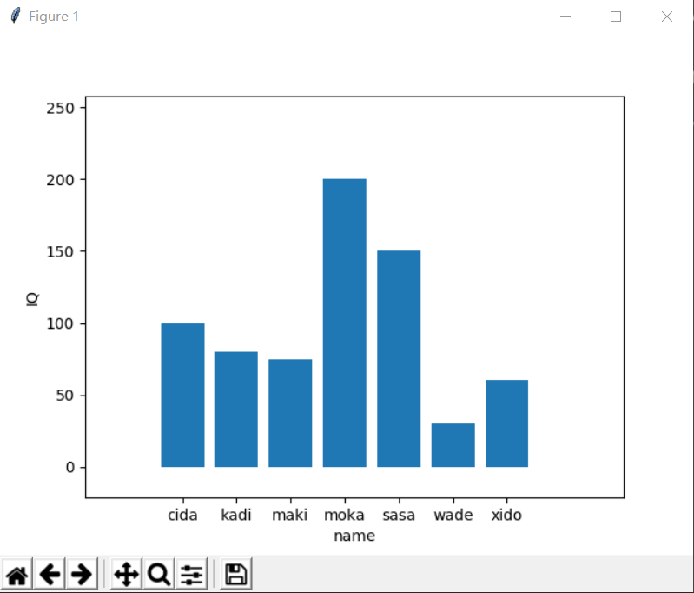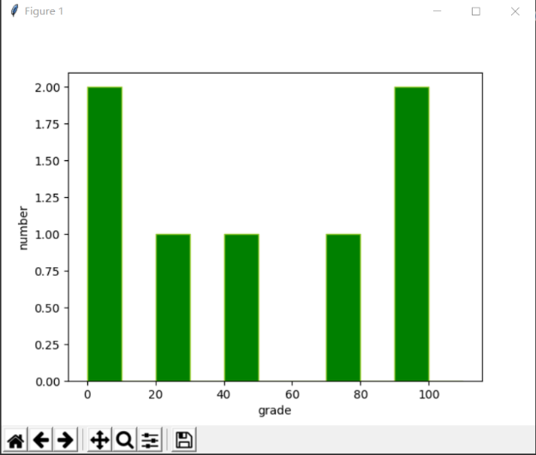

Above is just three examples, Table class has much more than above, which is already finished.

Why it is useful?

As you can see, LZDB is not just a data base that can perform sql functions. With matplotlib,

it could create a visualization of data conveniently. With future function, we can extract data, output data in any forms. Apply any kind of data structure on the data, make any changes without limitations (not like sql), even summarize that to a human-readable sentences or write a non-fixed function depended on the data in the table.

lazy data base is not for large data set. However, what is the last time you guys have a chance to touch 100,0000 rows of table? Have you guys work for a Top 500 Companies? as a programmer or a officer? However, small data set always appears, a 100-people company, a small restaurant, information of student or experiment data for assignment. Those stuff are usually less than 10,0000 rows (mostly less than 300 rows). Those data too large to handle by paper and pencil. At the same time, too small to use a SQLserver or sql. that’s the reason why we need a small and easy data base system.

What ever if you want apply a graph theory algorithm on those data? Or make a small progam with a relatively large data but not too large? SQL might work but certainly not easy.

Summarize:

It is a python data base project. That allow python perform all the functions that in the sql, and relational algebra. With python, we can do more stuff about the data (not just sql). we can even use scipy, what ever you learn in the other course to analyze data. we can even out put the data to a java 2d list, solve data base linear-system, spline functions, and make a prediction about future data input. This is not just save me and you time. It could help all the other programmers and lazy people.